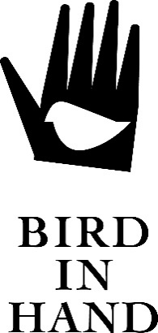

The Bird in Hand signature range is a limited release of premium quality wines created from the best parcels of fruit from every vintage. These wines present the character to age impeccably whilst delivering qualities that can be enjoyed today.

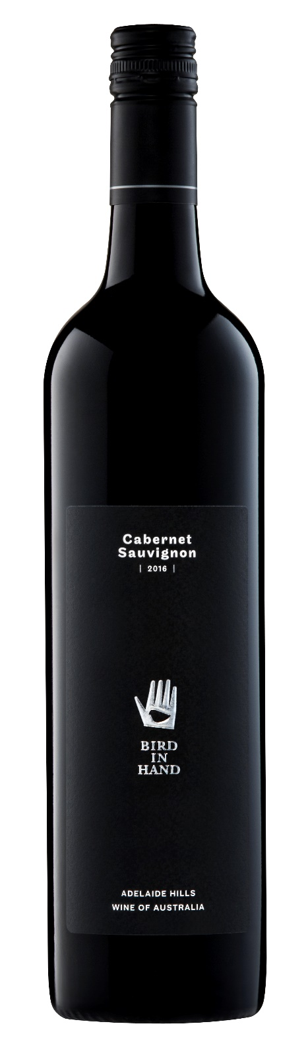
Bird in Hand

Cabernet Sauvignon 2016

ADELAIDE HILLS

Fruit for this Cabernet Sauvignon was carefully selected from several low yielding premium vineyards in Macclesfield, Birdwood and Kersbrook with an average vine age of 20 years.

The majority of the fruit spent between 7-10 days on skins to maximise colour, flavour and tannin extraction with a select batch left on skins for up to 28 days. The fruit was then transferred to French oak barriques for 18 months, 55% of which was new oak from coopers specifically selected for premium Cabernet. All vineyard parcels were kept separate right through to final blending stage.

This wine is a deep ruby in colour with maroon hues, and on the nose exudes concentrated and intense aromas and flavours of cassis, black plum, cedar and violet. On the palate, its full-bodied and fleshy, but with the classic structured character of a cool climate Cabernet Sauvignon, with long silky tannins on the finish.

The wine will cellar for several years, and is a great match for braised lamb with roasted shallots.

Technical Data
Alc: 14.5
pH: 3.61
TA: 6.23

